Anantha Lakshmi Institute of Technology and Sciences (ALITS)
Department of Data Science

Visualizing Housing Market Trends: An Analysis of Sale Prices and Features using Tableau
Project Design Phase — Proposed Solution

Project Name: Housing Market Trends using Tableau
Team ID: ALITS-DS-2026-HousingMarketTrends
Academic Year: 2026

Proposed Solution
Parameter | Description
Problem Statement | Home buyers and analysts lack an interactive, visual way to understand housing sale price trends and the impact of features like renovation, age, bedrooms, bathrooms, and floors.
Idea / Solution Description | Build an interactive Tableau dashboard suite from the Transformed Housing Data dataset — combining KPI summary cards, a sale-price distribution histogram, a house-age/renovation pie chart, and a feature-comparison bar chart into one Comprehensive House Price Analysis dashboard, supported by a 5-point guided storyboard.
Novelty / Uniqueness | Consolidates multiple analytical angles (scale, price distribution, renovation impact, structural features) into a single interactive view with a narrated storyboard — unlike static, single-purpose spreadsheet reports.
Social Impact / Value Proposition | Enables faster, more transparent, and more confident housing decisions for buyers and researchers, with zero coding required to interact with the insights.
Business Model (Revenue Model) | Academic project value and portfolio building; potential extension into freelance/consulting dashboard services for real-estate agencies.
Scalability of the Solution | The workbook structure can be extended with live data connections, additional geographic detail (zipcode groups already present in the dataset), and predictive analytics.

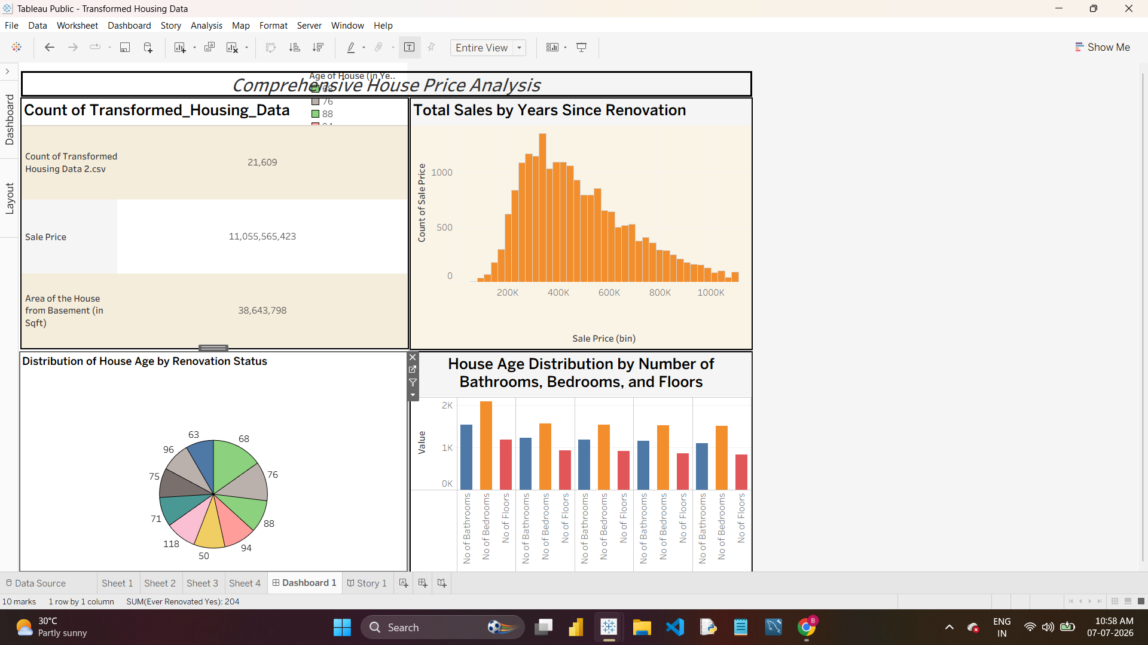
Figure 3.1: Actual Comprehensive House Price Analysis Dashboard built in Tableau Public

